Description on how to download Intraday US Stock and ETF data from IEX Cloud:

IEX, the Investors Exchange, provides APIs to fetch time series data for U.S. equity securities, including exchange-traded funds (ETFs). You may use your Test API in the sandbox or Production API in IEX cloud to retrieve data. However, IEX may scramble the free data for the sandbox.

Below example shows how to download 1-min intraday data for AAPL from any date within the trailing 30 calendar days. The date is expressed as yyyymmdd. Upgraded API is required for this url now.
https://sandbox-sse.iexapis.com/stable/stock/aapl/chart/date/20190702?token=your-Tsk-api
https://cloud.iexapis.com/stable/stock/aapl/chart/date/20190702?token=your-sk-api

Alternatively, if you just need the last day of data, you can choose getting from IEX only (free) instead of all the markets, like this:
https://cloud.iexapis.com/stable/stock/aapl/intraday-prices?chartIEXOnly=true&token=your-sk-api

Or for all the markets (require upgraded API):
https://cloud.iexapis.com/stable/stock/aapl/intraday-prices?token=your-sk-api

Eligible symbols are shown on https://iextrading.com/trading/eligible-symbols/

Set-up:

- Copy one the following lines and append to your existing “mywebserver.txt. It works for 1-min, 5-min, 6-min, 10-min, 15-min, 20-min, 30-min and 60-min intervals. Note that there are 3 different APIs.

IEX_Stock_IXXXX,https://cloud.iexapis.com/stable/stock/SSSS/chart/date/yy4ymm1mdddd?token= your-sk-api,I2,IEX_Stock_I2.fmt

IEX_Stock_IXXXX,https://cloud.iexapis.com/stable/stock/SSSS/intraday-prices?chartIEXOnly=true&token= your-sk-api,I1,IEX_Stock_Free_I1.fmt

IEX_Stock_IXXXX,https://cloud.iexapis.com/stable/stock/SSSS/intraday-prices?token=your-sk-api,I1,IEX_Stock_I1.fmt

- Copy the supplied “IEX_Stock_I2.fmt” file (or “IEX_Stock_Free_I1.fmt” or “IEX_Stock_I1.fmt) to the “fmt” subfolder under the Data File Location (indicated on the Preference screen).

- Set up the portfolio with the Interval you want.

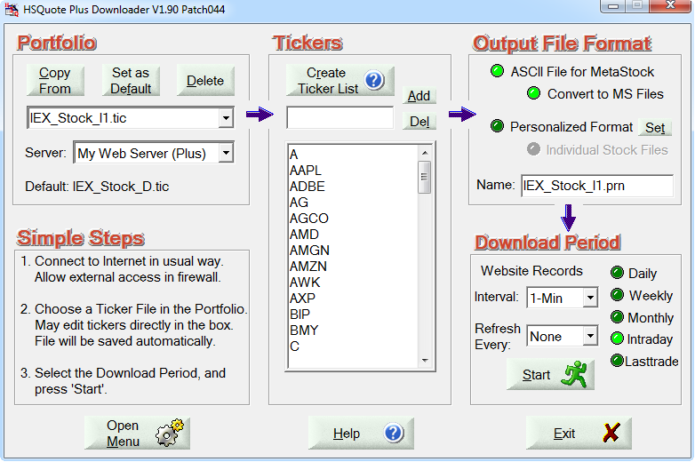

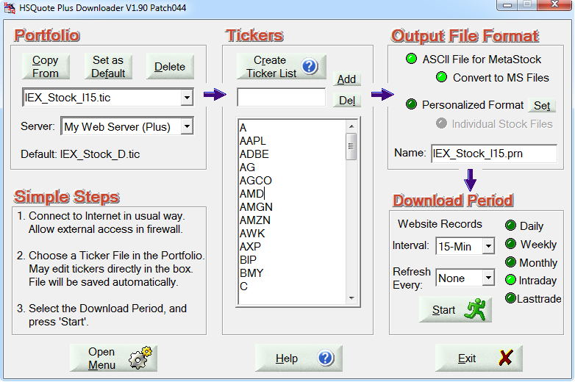

Download:

- Before download, switch the Download Period to Daily to indicate the Fr. Date and To Date. The Fr. Date should not be more than about 30 calendar days ago.

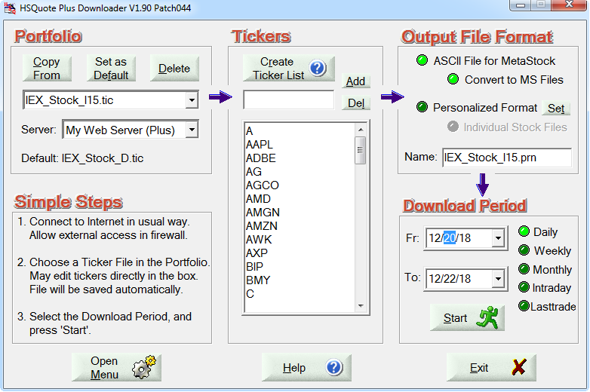

- Then switch back to Intraday to download Intraday data.

